Elisa Hertz The Data Scientist Toolbox

1. Installed R

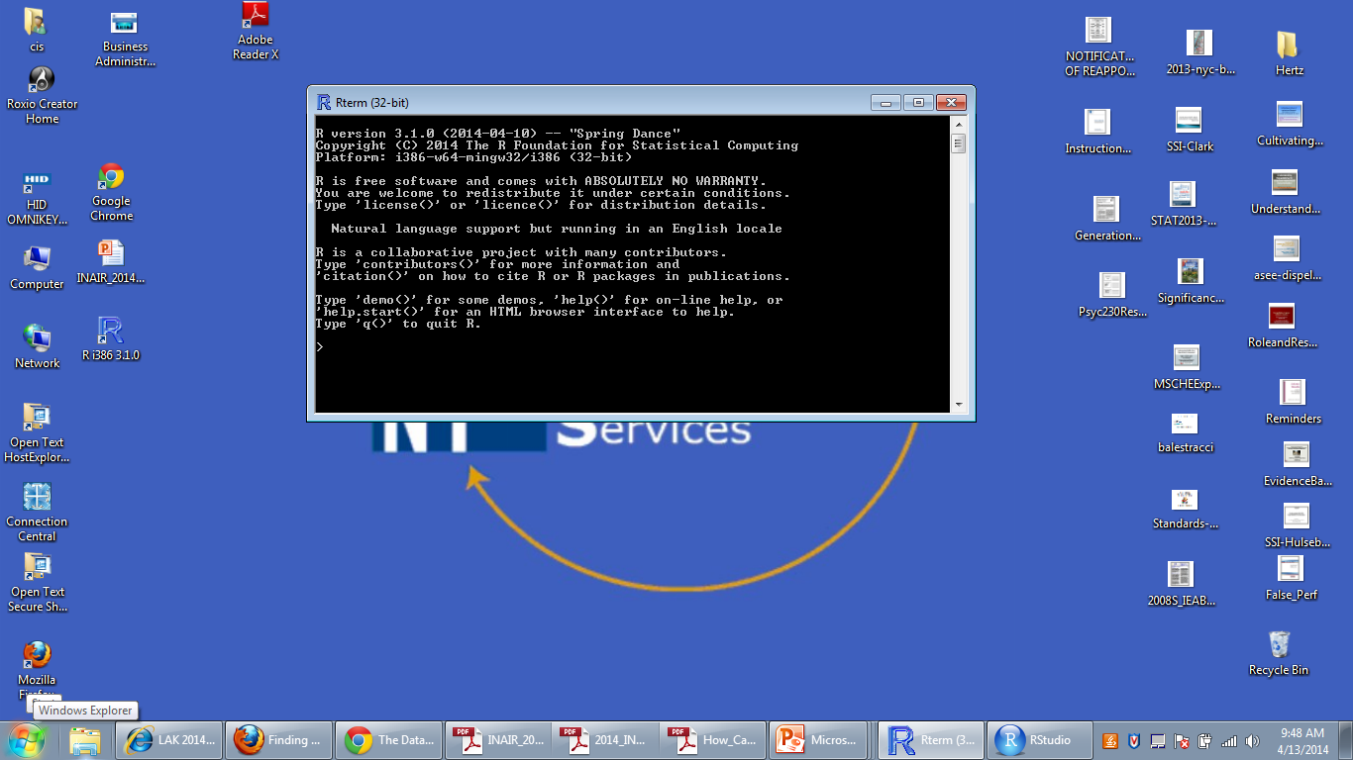

2. Installed R Studio

